**Masters**

* **Offices:** When we are trying to delete the Office name “**Chennai 1**” it shows below error **(done)**



* In region tab we do not have option to “**Save**”. It has Edit and View. Also, please advise the use of field “**Average volume per week prior to SSC volume<**”

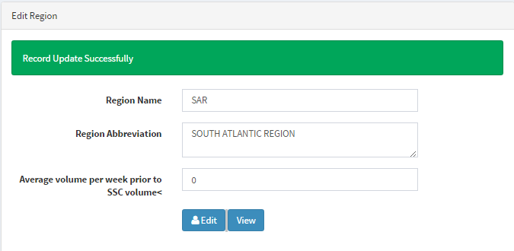

Also, even if we have entered only 6 regions, it is reflecting as 2 pages. Whereas, all the regions are reflecting on 1st page. **(done)**

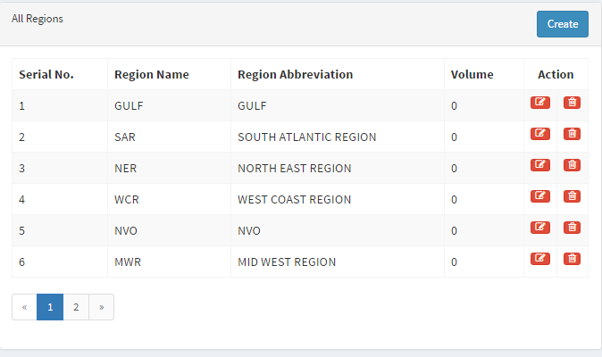

**Status:** When we added few statuses in “UPF” and “APF” separately, all the status is reflecting in “UPF” and “APF” it shall not be the case. **(done)**

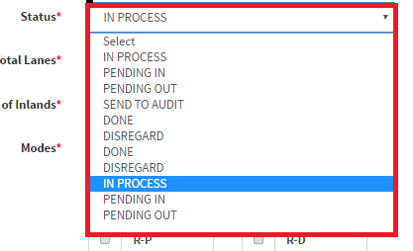

* Also, we can only view 5 records at a time. Please add a tab wherein if needed we can view all the record at once.



* **Commodity:** We must be able to download the database.
* Please add “**Back end data**” tab so that we can download all the data updated in CIRA.

**Indexing:**

**Mail Received Date & Time** – It auto pull system date and time I/O the mail timing. When we try to Copy paste mail received date and time from mail to CIRA

**Priority:** It shall be default as “**STANDARD**” **(done)**

**Request type**: It shall be default as “**NEW**” **(done)**

**Office**: It shall be default as “**Mumbai 1**” **(done)**

Also, once a record is saved the cursor shall move back to “**Mail received date and time**” **(done)**

**Container Type:** If the container type is marked as reefer it’s TAT will be 24 hrs but please highlight all the reefer requests in red color background. **(done)**

**Publishing:**

* TAT calculation is wrong. I have indexed a dummy request at 8.46 EST but the TAT pending minutes states 24:48. **(done)**

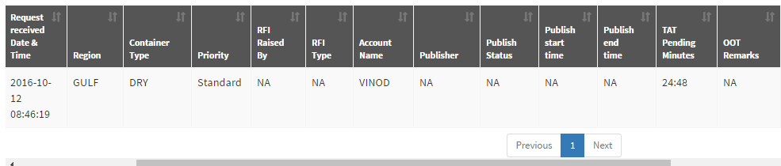

* Add a column filter so that the user can filter the columns needed by him and hide other columns.

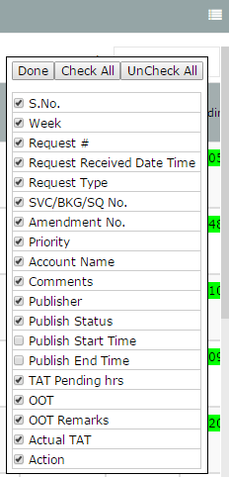

* **Request No.:** As soon as the user clicks on the “**Unique key”** the request must be assigned and auto saved in the name of that particular user and the status must be “**In Process**”. Also, the same must reflect on the dashboard.
* **“Request type**” does not reflect in publishing queue. **(done)**
* All the “Request Type” which is marked as Correction shall be highlighted in red color background **(done)**

**UPF**

* In UPF we must only have 6 status i.e. **“In Process”, “Pending IN”, “Pending Out”,** “**Sent to Audit**”, “**Done**” and “**Disregard**”. **(done)**
* If the status is **“In Process”, “Pending IN”, “Pending Out”** it shall not be mandatory to update “**Total lanes**”, “**No. of Inlands**”, “**Modes**”. It shall be mandatory only if the status is “**Sent to Audit**”, “**Done**” and “**Disregard**”. **(done)**
* **“Request type” and “User name”** must be grayed out to Users. **(done)**
* In Publishing Queue “Action” field shall not be available to Users. **(done)**
* **No. of Inlands:** It states value must be greater than or equal to 1, whereas inland can be 0 if the mode is only P-P. **(done)**
* **Commodity:** Commodity tab which is mandatory if the Container Type is Reefer shall be free text.
* UPF form shall be directed to publish queue as soon as the status is changed and saved. **(done)**
* If the Users selects the status **“Pending IN”** kindly addone more mandatory field i.e. **“ISR initiated”** and it shall be Free Text
* Suppose in a particular request if the User raises a query twice i.e. “Pending IN” twice the dashboard is reflecting the latest query only.

**APF:**

* In APF we must only have 5 status i.e. **“In Process”, “Pending IN”, “Pending Out”,** “**Done**” and “**Disregard**”. **(done)**
* Add a column filter so that the user can filter the columns needed by him and hide other columns.



* **Request No.:** As soon as the auditor clicks on the “**Unique key”** the request must be assigned and auto saved in the name of that particular user and the status must be “**In Process**”. Also, the same must reflect on the dashboard.
* Currently as soon as the auditor opens the **APF** the status is reflecting as “**Sent to Audit**” which is from **UPF**. It shall be “**In Process**”
* Whenever we are updating any status in “Audit” queue it shows below error. **(done)**



* In “APF” we must have “Total Lanes”, “No. of Inlands” and “Modes” tabs.